# Objective

You will write a method to create a personal logo or image at a specified spot on the screen. You will incorporate translation and rotation to easily recreate the image at various locations and orientations on the screen.

## Topics: methods, parameters, translation, rotation, vector primitives, shapes

# Instructions

On graph paper, design a personal symbol or logo. Create your design centered on the origin. It should be no wider or taller than 100px. Use a variety of shapes, such as lines, rectangles, ellipses (circles), and n-sided polygons. Use the methods we discussed in class, such as **line(**x1,y1,x2,y2**)**; **rect(**x, y, w, h**)**; **ellipse(**x, y, w, h**)** and **beginShape()** , **endShape(CLOSED)** and **vertex(x, y)**.

Once you have planned your shape, implement a method to draw the shape, centered on the origin. Use the flowing method signature:

void **drawSymbol**(float x, float y, float angle)

Within the method, you will use the **pushMatrix(), translate(), rotate()**, and **popMatrix()** methods to manipulate the *graphics context*. Check the Processing reference for details, and see the tutorial at <http://processing.org/learning/transform2d/> for further help.

# Hints

You may wish to use **rectMode(**CENTER**)** and **ellipseMode(**CENTER**)** to make the drawing of your symbol easier.

# Examples

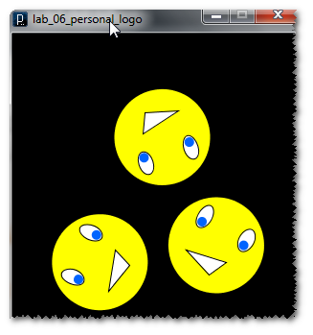

# Challenge

Add an additional parameter, float scale, to your **drawSymbol()** method. Use the value of that variable and the Processing  
**scale(**float amt**)** method to scale your symbols.